RIVER AND EROSINAL LANDFORMS

# River

A river is a large, natural stream of flowing water. Rivers are found on every continent and on nearly every kind of land.

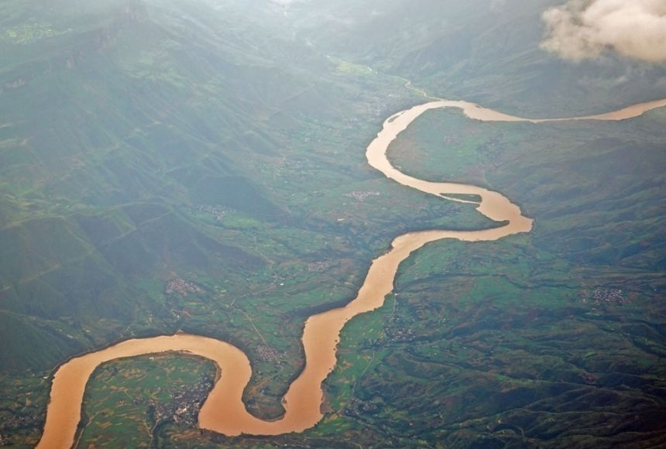

Types of rivers

* Seasonal rivers
* Permanent river

# Erosional processes

Erosion is the gradual removal of top soil by its agents.

# Agents of erosion

* soil
* wind
* animals
* running water

**Types of erosion**

Erosion is the process that wears away the river bed and banks. Erosion also breaks up the rocks that are carried by the river.

There are four types of erosion:

* **Hydraulic action** - This is the sheer power of the water as it smashes against the river banks. Air becomes trapped in the cracks of the river bank and bed, and causes the rock to break apart.
* **Abrasion** - When pebbles grind along the river bank and bed in a sand-papering effect.
* **Attrition** - When rocks that the river is carrying knock against each other. They break apart to become smaller and more rounded.
* **Solution** - When the water dissolves certain types of rocks, eg limestone.

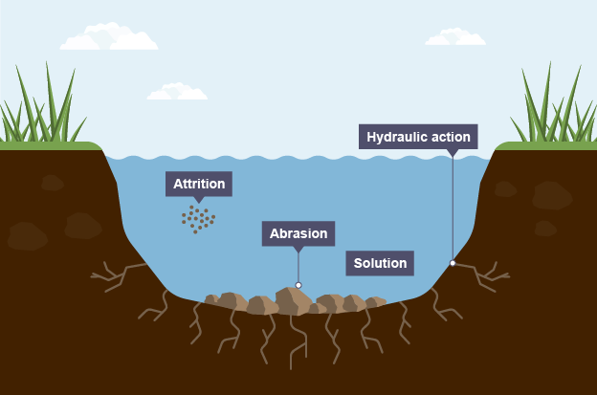

**Types of transportation**

The river picks up sediment and carries it downstream in different ways.

There are four types of transportation:

* **Traction** - large, heavy pebbles are rolled along the river bed. This is most common near the source of a river, as here the load is larger.
* **Saltation** - pebbles are bounced along the river bed, most commonly near the source.
* **Suspension** - lighter sediment is suspended (carried) within the water, most commonly near the mouth of the river.
* **Solution** - the transport of dissolved chemicals. This varies along the river depending on the presence of soluble rocks.

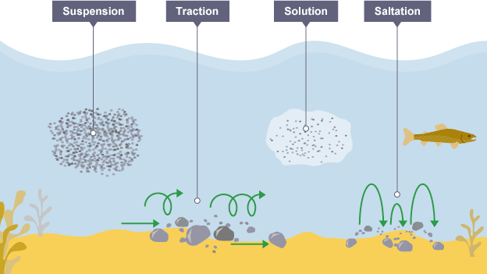

**Deposition**

When the river loses energy, it drops any of the material it has been carrying. This is known as [**deposition**](https://www.bbc.co.uk/education/guides/ztpkqty/revision).

Factors leading to deposition:

* shallow water
* at the end of the river's journey, at the river's mouth
* when the volume of the water decreases

**Drainage basins**

A river's water can fluctuate over time. Understanding the [**hydrological cycle**](https://www.bbc.co.uk/education/clips/z4n9wmn) is useful in order to understand how and why the amount of water fluctuates.

A drainage basin is the area of land around the river that is drained by the river and its tributaries.

* **Watershed** - the area of high land forming the edge of a river basin
* **Source** - where a river begins
* **Mouth** - where a river meets the sea
* **Confluence** - the point at which two rivers meet
* **Tributary** - a small river or stream that joins a larger river
* **Channel** - this is where the river flows

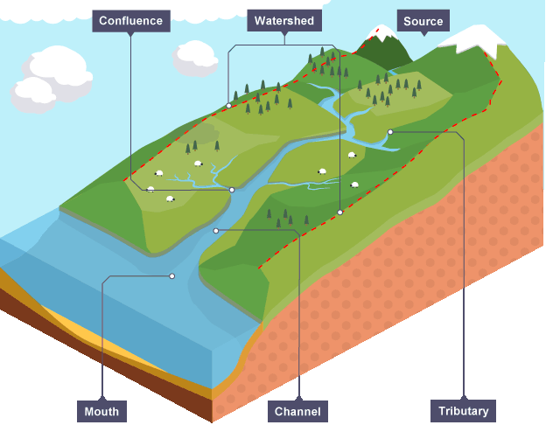

# River profiles

## Long profile

A long profile is a line representing the river from its source (where it starts) to its mouth (where it meets the sea). It shows how the river changes over its course.

* **Upper course** - in the upper course, where the river starts, there is often an upland area. The river's load is large in the upper course, as it hasn't been broken down by erosion yet.
* **Lower course** - in the lower course, the land is a lot flatter. The river's load is fine sediment, as erosion has broken down the rocks.

## Cross profile

A cross profile shows a cross-section of a river’s channel and valley at a certain point along the river’s course.

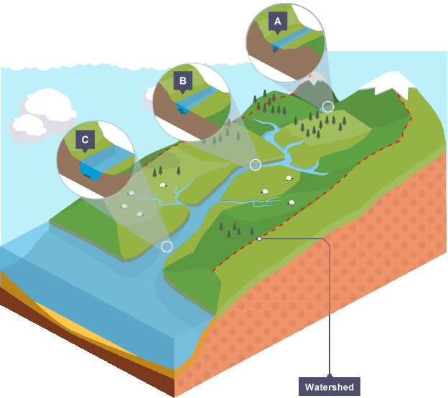

* **A** - as the river flows downhill there is an increase in vertical erosion. The channel is shallow and narrow because there is not a lot of water in the channel.
* **B** – as the river flows into the middle course, there is some vertical erosion but more lateral erosion. The channel is wider and deeper as a result.
* **C** - in the lower course there is a lot less erosion, with only some lateral erosion. The channel is at its widest and deepest.

# Erosional landforms

The process of erosion can create different landforms. The erosional features are often found in the upper course of the river.

## Waterfall and gorges

A waterfall is a sudden drop along the river course. It forms when there are horizontal bands of resistant rock (hard rock) positioned over exposed, less resistant rock (soft rock).

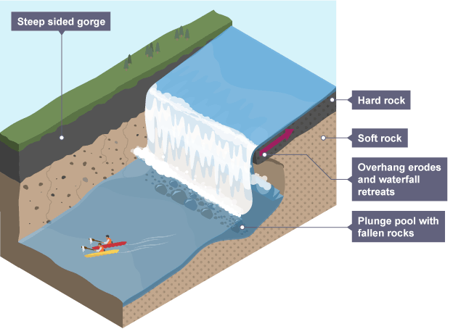

1. The soft rock is eroded quicker than the hard rock and this creates a step.
2. As erosion continues, the hard rock is undercut forming an overhang.
3. Abrasion and hydraulic action erode to create a plunge pool.
4. Over time this gets bigger, increasing the size of the overhang until the hard rock is no longer supported and it collapses.
5. This process continues and the waterfall retreats upstream.
6. A steep-sided valley is left where the waterfall once was. This is called a gorge.

Gorge   
a gogre is a deep narrow steep valley or a clif sided created mainly the vertical erosive action of the youthfull stage

Gorges also known as canyons.

[image[

Formation

A gorge is formed where there are alternative resistant rocks and less resistant rocks.  
when a river flows over a band of the resistant rocks, its speed of cutting down its river bed is reduced .

However when it reaces a less resistant rocks downstream, its erosive activity increases.

The river is e=able to cut down to int its channel bed more quickly than it erodes is walls.

As the erosion continues over the years, the waterfalls recedes upstream and a deep, narrow steep sided valley is formed which is a gorge as shown bellow

[image]

Example of gorges

* The kafue grge in Zambia on r.kafue
* Kalambo river in Zambia has a deep gorge on its upper couse
* R.zambezi at the border of Zambia and Zimbabwe
* The batoka gorge and several other gorges on the zambezi river
* The congo orange, volta, kaduna, limpoppo, and the nile have gorges

Importances of gorges

1. Gorges are important tourist attractions which earns money to their countries which can be used to develop other sectors like minning.
2. The sites of gorges areassociated with waterfalls which are potential for generating hydro electric power fr domestic and industrial use.
3. Gorges are used as points where roads and railway lines can cross the river because they are narrow which reduces cost of construction
4. Gorges are sites of recreation and relaxation activities which has promoted leisuremin Africa
5. Gorges are used as for study puposes by sudents of geography and geophysics which promotes education oof Africa

Diadvatages of gorges

* The y hider navigation since there are water vessels that can travel in them

## Interlocking spurs

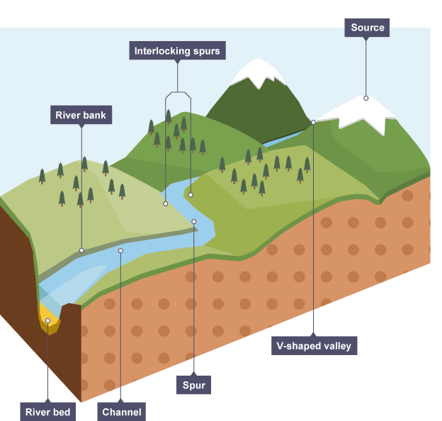

In the upper course there is more vertical erosion. The river cuts down into the valley. If there are areas of hard rock which are harder to erode, the river will bend around it. This creates interlocking spurs of land which link together like the teeth of a zip.

# Erosional and depositional landforms

## Meanders

As the river makes its way to the middle course, it gains more water and therefore more energy. Lateral erosion starts to widen the river. When the river flows over flatter land they develop large bends called meanders.

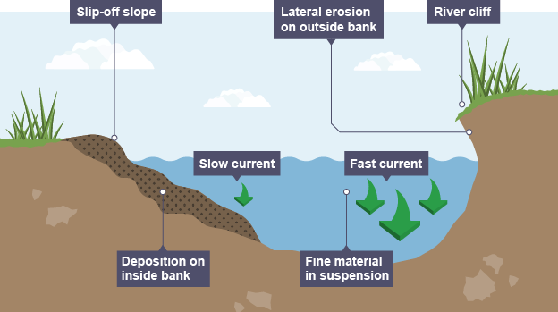

* As a river goes around a bend, most of the water is pushed towards the **outside**. This causes increased speed and therefore increased erosion (through hydraulic action and abrasion).
* The lateral erosion on the outside bend causes undercutting of the bank to form a river cliff.
* Water on the inner bend is slower, causing the water to slow down and deposit the eroded material, creating a gentle slope of sand and shingle.
* The build-up of deposited sediment is known as a slip-off slope (or sometimes river beach).

## Oxbow lakes

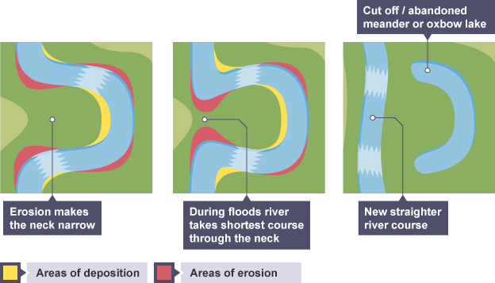

Due to erosion on the outside of a bend and deposition on the inside, the shape of a meander will change over a period of time. Erosion narrows the neck of the land within the meander and as the process continues, the meanders move closer together. When there is a very high discharge (usually during a flood), the river cuts across the neck, taking a new, straighter and shorter route. Deposition will occur to cut off the original meander, leaving a horseshoe-shaped oxbow lake.

An oxbow lake starts out as a curve, or meander, in a river. A lake forms as the river finds a different, shorter, course. The meander becomes an oxbow lake along the side of the river.  
  
Oxbow lakes usually form in flat, low-lying plains close to where the river empties into another body of water. On these plains, rivers often have wide meanders.  
  
Meanders that form oxbow lakes have two sets of curves: one curving away from the straight path of the river and one curving back. The corners of the curves closest to each other are called concave banks. The concave banks erode over time. The force of the rivers flowing water wears away the land on the meanders concave banks.  
  
The banks opposite the concave banks are called convex banks. The opposite of erosion happens here. Silt and sediment build up on convex banks. This build-up is called deposition.  
  
Erosion and deposition eventually cause a new channel to be cut through the small piece of land at the narrow end of the meander. The river makes a shortcut. Oxbow lakes are the remains of the bend in the river.

# Depositional landforms

## Floodplains

A floodplain is an area of land which is covered in water when a river bursts its banks.

Floodplains form due to both erosion and deposition. Erosion removes any interlocking spurs, creating a wide, flat area on either side of the river. During a flood, material being carried by the river is deposited (as the river loses its speed and energy to transport material). Over time, the height of the floodplain increases as material is deposited on either side of the river.

Floodplains are often agricultural land, as the area is very fertile because it's made up of alluvium (deposited silt from a river flood). The floodplain is often a wide, flat area caused by meanders shifting along the valley.

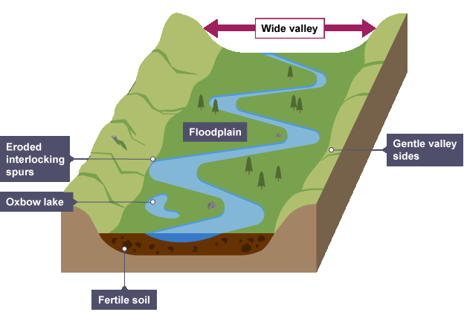

Impotance of flood plains

1. Flood plains have fertile soils which promote crop growing like the chari river flod plain for potatoes, cultivation on the sides of the flod plains of Morocco, the nile in egypt
2. Flood plains are uses as easy places of construction of transport settlement and industrial establishment eg in Egypt the roads follow the the river nile.
3. Flod plains are relable souces of water for river erosion as the river flow is very calm and the place has fertile soils that support an vast array of food and cash crops that can provide food and money.
4. Forested flood plains have promoted lumbering and provided other usefulll stuff lie timber and firewood which his used for household use and industrial use and for the furniture industry
5. Flood plains have pastues which support animal rearing ed=g the eunai pastoralists depend on the r.niger
6. Sand amd bouldes deposited on the flood plains during flood times are mined thus thus a source of income and providing the people withw raw materials for building
7. They are a tourist attractions thus a source of income for their countries which use the income for ther soures
8. Flood plains are used by geography students for geographical purpose

Problems faced

* Flood plains are subjected to flooding which results to the the destruction of property, loss of lives which cause devstations.
* The stagnant water in the flood plain acts as breeding grounds for pests and disease-causing vectors that spread disease that can lead to loss of lives
* Flood plains dry out during the dry season which results into shortage of water
* Flood plains suffer from over crowding and land fragmentation because they attract lagre crowds of people for settlement

Measures to the abve problems

* Constructing special channels to divert flood waters away from the residential areas
* Constructing dams for contorliing floods like aswan high dam on the nile river
* Constructing artificial leeves whichact as barriers to flood waters during heavy rains
* Regular dredging is carried to deepen the channel and reducing flooding
* Afforestation and re a ffoestation are being carried out f=to prevent too much silting
* Evacuation of peple to safer areas in cas of flooding

## Levees

* Levees occur in the lower course of a river when there is an increase in the volume of water flowing downstream and flooding occurs.
* Sediment that has been eroded further upstream is transported downstream.
* When the river floods, the sediment spreads out across the floodplain.
* When a flood occurs, the river loses energy. The largest material is deposited first on the sides of the river banks and smaller material further away.
* After many floods, the sediment builds up to increase the height of the river banks, meaning that the channel can carry more water (a greater discharge) and flooding is less likely to occur in the future.

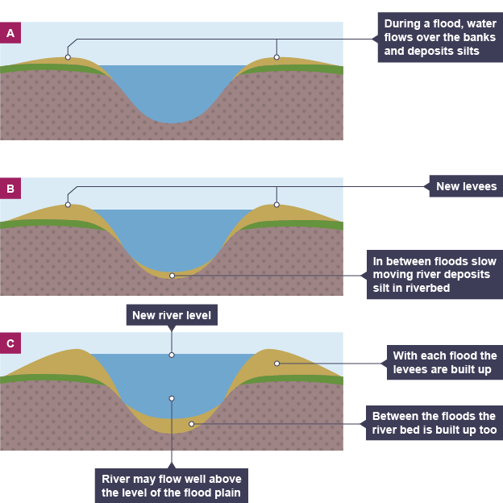

## Estuaries

An estuary is where the river meets the sea. The river here is tidal and when the sea retreats the volume of the water in the estuary is reduced. When there is less water, the river deposits silt to form mudflats which are an important habitat for wildlife.

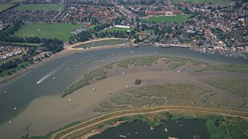

The place where a river enters a lake, larger river, or the ocean is called its mouth. River mouths are places of much activity.  
  
As a river flows, it picks up sediment from the river bed, eroding banks, and debris on the water. The river mouth is where much of this gravel, sand, silt, and clay—called alluvium—is deposited.  
  
When large amounts of alluvium are deposited at the mouth of a river, a delta is formed. The river slows down at the mouth, so it doesn’t have the energy to carry all the silt, sand, and clay anymore. These sediments form the flat, usually triangle-shaped land of a delta. Examples of deltas are the Nile River Delta in Egypt

The mouth of a river is often a good place for fishing. Along with the alluvium, a river flushes many different species into the lake or sea. Larger fish sometimes wait at the mouth of the river for an easy meal. Thanks to the current of the river, the large fish have a “buffet” of smaller bait fish. This meeting of big and small fish means there is more for people to catch.  
  
But fish can hide at river mouths, too. The current changes here, and fish The destruction of a river’s mouth can devastate the surrounding area. The Colorado River naturally flows into the Sea of Cortez, in Mexico. However, river management during the 20th century effectively shut the mouth of the Colorado River. Freshwater only reaches the Colorado River Delta when reservoirs created by artificial dams are full. Native species, such as cottonwood trees and the Colorado Delta clam, are endangered because of their lack of habitat.  
Many major port cities have been built at river mouths. The abundant wildlife and natural transportation often create dynamic harbors and ports

Delta

A delta is alagre flat lowlying plain of river deposits built by a river mainli in the old stage where it flows in the sea or lake most deltas have a triangular shape.

As a river enters calmly waters of a sea or a water body it deposits its load at the mouth of the river and the deposits block the river in response the rivers tthne continuous split because of the load that it might find

Patches ofn water are enclosed within the sediments deposited to form lagoons as well as swamps then the delta is colonized by plants that makes it to rise

[image required]

Importance of deltas to man

* deltas contains fertile alluvial soils that have promoted cultivation hence providing food and raw materials for agro based industries.eg on the river nile delta there is heavy agricultural industry
* the deltas have promoted livestock rearing because the y contain swampy vegetation and they also contain grass for feeding animals
* deltas are ideal areas of settlement , development, of industries, transport because they are generally flat and thus promoting growth and development of the areas eg cairo has become one of the most developed areas in the world
* they are great tourist atttractions hence earning foreign exchange to the respective countries so that the money can be chanelled else where
* many deltas contain petroleum deposits which has promoted mining that provides fuel for all sorts of uses eg the the Niger and Nile deltas
* many deltas especially those in the tropics have promoted lumbering which provide wood and timber for other purposes eg the nile delta is forested
* deltas have promoted the art and craft industry because they have the reeds and papyrus and clay for the making of these items eg pots and mats
* deltas are used for study purposes by many people including geographers and botanical students

problems faced by these people

* over crowding
* hot temperatures
* the salinity of the water retards the effectivement of the water
* disease due to the vectors and pests around
* flooding

importance of rivers

* rivers are important sources of waters for domestic and industrial use
* rivers have promoted irrigational farming by providing water for irrigation
* rivers have promoted livestock rearing because they provide water to feeed animals
* rivers provide fertile deposit that provide space from farming that inturn that provides raw materials and food
* rivers in the old stage are cheap means of transport that also promoted trade
* rivers have promoted development of urban centers
* rivers wth waterfalls are important sources of the generation of hydro electric power
* some rivers are sources of minerals like petroleum and alluvial diamonds from r.orange which provides in turn foreign exchange
* rivers are sources of rish that provides us with proteins
* some rivers act as boundaries between countries that promotes peacefull existance eg r.Ubangi that forms a boundaries with Central African Republic
* rivers are tourist attractions that ern foreign income
* rivers are recreation grounds

problems faced by people along river valleys

* river valleys act as habitat for diease spreading vectors
* river valleys are subjected to flooding especially during the rain season thus leading to the destruction of crops and animals and lives as well
* rivers with waterfalls and rapids make navigation difficult which hinders transport
* river valleys in the desrt regions ot=ften face over-congestion
* shortage of land in the river valley due to over population
* pollution of the rivers which makes the water unfit for human and animal consumption
* rivers hinder transport pbecause it is hard to construct roads on them hence remoteness
* soil erosion and wide spread siltation hider thetransportation on rivers
* attacks from dangerous wild aninmalls that reside in the river
* water reeds which limits rishing as well as tansport

solutions to the above problems

* use of locks to by pass dams which were dams limit transport eg n the kainji dam
* establishment of industries outside river valleys to reduce congestion
* construction of dams and and artificial leeves to control flooding
* regular dredging of river valleys to reduce silting of rivers and flooding during rainy seasons
* resettlement of people from the the congested areas of river valleys to other areas
* enacting laws against wate pollution and water treatment of industrial waste planting trees along rivers to curb siltation
* eradication or water weeds by various means eg mechanical and use of pests t feed n them